**Enhancing Multiclass Skin Lesion Classification: A Deep Learning vs. Hybrid Deep Learning-Machine Learning Comparison on ISIC-2017 and HAM10000 Datasets**

**Daniel Tweneboah Anyimadu123*, Taofik Ahmed Suleiman123**

1. Department of Medical Imaging and Computing, University of Girona, Spain
2. Graduate School of Science and Technology, Medical Imaging and Applications (MAIA), University of Burgundy, France
3. Department of Electrical and Information Engineering, MAIA, University of Cassino and Southern Lazio, Cassino, Italy

Email: [dtanyimadu@gmail.com](mailto:dtanyimadu@gmail.com), taofik-ahmed_suleiman@etu.u-bourgogne.fr

**Abstract:**

Skin lesion classification in medical imaging has two main objectives: providing targeted information and treatment options for specific lesions, as well as early and accurately detecting skin cancer with reasonable sensitivity and specificity. However, variations in skin lesions and imbalanced datasets pose significant challenge to skin lesion multiclassification tasks. To address this, complex deep and machine learning techniques have been leveraged to improve performance in such tasks. Despite the progress, there still remains paucity in research comparing pure deep learning with hybrid deep learning-machine learning models for skin lesion multiclassification tasks. This project aims to bridge that gap by comparing these two approaches, while enhancing multiclass skin lesion classification. The project involves data acquisition and preprocessing, development of CNN architecture, classification and feature extraction, training and fine-tuning of machine learning models, and evaluation of performance. The experiment is conducted using the publicly available International Skin Imaging Collaboration (ISIC) 2017 Skin Lesion Classification dataset. Balanced Multiclass Accuracy (BMA) metric, alongside overall accuracy, were leveraged for evaluating our multiclassification models, considering class imbalances. The results demonstrate that the hybrid model outperforms the pure deep learning approach, achieving a 90.56% accuracy and 90.56% BMA compared to 85.18% accuracy and 85.20% BMA for pure deep learning. To further validate our findings, we leveraged the proposed algorithm on the HAM10000 (Human Against Machine with 10000 training images) dataset. The results unequivocally showcase the superiority of the hybrid model over the pure deep learning approach, achieving an impressive accuracy of 92.21% and a BMA of 92.21%, as opposed to 85.33% accuracy and 85.45% BMA obtained by the pure deep learning approach. These findings serve as practical springboard for further innovation in AI-powered diagnostic tools, benefiting healthcare in dermatology and beyond. The source code to the project can be publicly accessed at …

**Keywords:** deep learning, convolutional neural network, machine learning, multiclassification, skin lesion.

# 1.0 INTRODUCTION

Skin lesion classification in the domain of medical imaging, is vital for early and accurate diagnosis of skin diseases (Wu et al., 2022). Skin cancer encompasses various types, including squamous cell carcinoma, basal cell carcinoma, and melanoma, each with distinct characteristics (vascular lesion, benign keratosis, dermatofibroma, actinic keratosis, melanocytic nevus) (Afza et al., 2022). Among them, melanoma presents significant life-threatening dangers (Atkins et al., 2021). This skin cancer type arises from uncontrolled proliferation of melanocyte due to excessive UV radiation exposure (van der Weyden et al., 2020). Various modalities employed for skin cancer treatment include surgical excisions, radiation therapy, chemotherapy, immunotherapy, and targeted medicines (Board, 2023; Zeng et al., 2023). However, there still remains an increased morbidity and mortality rate due to delayed diagnosis and misdiagnosis associated with complexity and diversity of skin textures and lesions (Gilli et al., 2022). Current and prevalent traditional dermoscopic imaging relies on expert visual analysis, which is often arduous, laborious, subjective and inconsistent in diagnostic accuracy (Blundo et al., 2021; Shen et al., 2019).

Nonetheless, to mitigate the limitations of conventional dermoscopic imaging, image-based Computer-aided Diagnosis (CAD) has been developed (Kassem et al., 2021; Khattar & Kaur, 2022). Deep learning (DL) models, such as Convolutional Neural Networks (CNNs), have shown remarkable success in a wide range of computer vision tasks, including image recognition and classification (Alzubaidi et al., 2021; Sarker, 2021; Taye, 2023). The hierarchical structure of CNNs allow them to automatically learn discriminative features from raw image data, capturing both local and global patterns (Taye, 2023). Similarly, machine learning (ML) algorithms, have been widely used in medical image analysis due to their interpretability and ability to handle imbalanced datasets (Hakkoum et al., 2022; Sharma & Shah, 2021; Varoquaux & Cheplygina, 2022). Leveraging DL and ML techniques into classifying skin lesions harness CNNs' feature extraction capabilities and ML classifiers' interpretability and robustness (Fong et al., 2023; Linardatos et al., 2020). These approaches enhance skin lesion classification, address imbalanced datasets and offer valuable decision-making insights.

DL and ML models are now the state of the art in skin lesion classification (Bechelli & Delhommelle, 2022; Kassem et al., 2021). Binary classification of malignant melanoma versus benign nevi was the most commonly implemented skin lesion detection task (Michalska-Ciekańska, 2022; Wu et al., 2022). Currently available complex DL and ML architectural models enable accurate multiclassification of 3 to 7 different skin lesions (Tahir et al., 2023). In light of these advancement, here, we classify three types of skin lesions (benign, seborrheic keratosis, and melanoma) using two approaches: pure deep learning with CNNs and a hybrid deep learning-machine learning model. The pure DL model uses CNNs for feature extraction and classification, while the hybrid approach combines a pre-trained CNN with the best performing machine learning classifier (random forest) for final classification.

# 2.0 RELATED WORK

Several studies have explored the effectiveness of multiclassification for predicting skin lesions, demonstrating their relevance in medical diagnosis. One such study by Afza et al.(Afza et al., 2022), proposed a hybrid deep learning approach that combines feature selection and Extreme Learning Machine (ELM) for accurate multiclass skin lesion classification. The method effectively distinguishes between various skin diseases, such as benign, seborrheic keratosis, and melanoma, and achieves improved classification performance accuracy rates of 93.40% and 94.36% on the HAM10000 and ISIC2018 datasets respectively by leveraging the strengths of deep features selection and ELM. Other notable studies are summarized in the following table (Table 1).

Table 1: Key studies in multiclass skin lesion classification

|  |  |  |  |  |
| --- | --- | --- | --- | --- |
| Author(s) | Dataset(s) | Aim(s) | Performance(s) | Drawback(s) |
| (Maqsood & Damaševičius, 2023) | HAM10000, ISIC2018, ISIC2019, and PH2 | To develop a unified CAD model using deep learning for multiclass skin lesion segmentation and classification | 98.57% accuracy achieved on HAM10000, 98.62% on ISIC2018, 93.47% on ISIC2019, and 98.98% on PH2 datasets | Reliance on pre-trained models and computational complexity associated with the fusion of deep features |
| (Iqbal et al., 2021) | ISIC-17, ISIC-18, and ISIC-19 | To develop an advanced Deep Convolutional Neural Network (DCNN) model for automated multi-class classification of skin lesions | Precision (94%), sensitivity (93%), and specificity (91%) were achieved on ISIC-17 dataset | Reliance solely on proposed DCNN model for classification task |
| (Usama et al., 2022) | HAM10000 | To improve skin cancer classification through an innovative method that utilized hybrid and optimal feature selections | Accuracy levels of 95.9%, 95.0%, and 95.8% were reached for cubic SVM, quadratic SVM, and ensemble subspace discriminants, respectively | Reliance on only pre-trained models and transfer learning for feature extraction |

The aforementioned studies underscore the significance of multiclassification, deep learning, and machine learning for accurate skin lesion classification. Nevertheless, a research gap persists concerning a comprehensive evaluation that contrasts pure deep learning against hybrid deep learning-machine learning frameworks within the context of multiclass skin lesion classification. Addressing this gap, our study employs a dual-prolonged methodology: the first utilizing pure deep learning through CNNs, and the second utilizing a hybrid deep learning-machine learning model to enhance multiclassification of skin lesions. Through this comparison, we seek to achieve superior skin lesion classification and diagnosis.

# 3.0 METHODOLOGY

This section presents a comprehensive framework to enhance skin lesion classification by addressing the challenges of multiclass classification. The approach involves data acquisition and preprocessing, development of CNN architecture, classification and feature extraction, training and fine-tuning of machine learning models, and evaluation of performance as depicted in (figure 1).

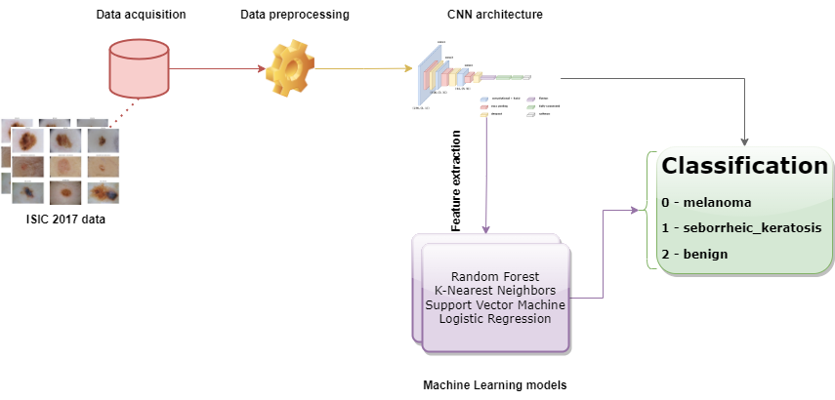

Figure 1: A flow diagram illustrating the methodology of the multiclassification task.

## 3.1 DATA COLLECTION AND PREPROCESSING

Within this section, we outline our approach to handle diverse challenges inherent to skin lesion datasets. We discuss data source acquisition, the intricacies of groundtruth handling, the insights gleaned from exploratory data analysis, the pivotal role of data preprocessing and labelling, strategic resampling techniques to tackle class imbalances, the formulation of training and test sets, and the vital normalization of image pixel values. Our conscientious decisions and meticulous processes set the foundation for robust and unbiased model evaluation within our research context.

### 3.1.1 Data Source and Groundtruth Handling

The dataset used in this study is the publicly available International Skin Imaging Collaboration (ISIC) 2017 Skin Lesion Classification dataset, containing 2000 lesion images in JPEG format (F Codella et al., 2017). Clinical metadata for each dermoscopic image, including "image_id", "age_approximate", and "sex" information are also available in a csv file. To enable supervised learning and performance assessment of classification models, groundtruth labels for "melanoma (374)", "seborrheic keratosis (254)", and "benign nevi (1372)" lesions are provided separately in a csv file. In other to facilitate efficient data manipulation and exploration, the metadata and groundtruth data are loaded into a pandas dataframe. The skin lesion images are mapped to their respective "image_id" using the Python glob function. The (figure 2) below illustrates various examples of different skin lesion types.

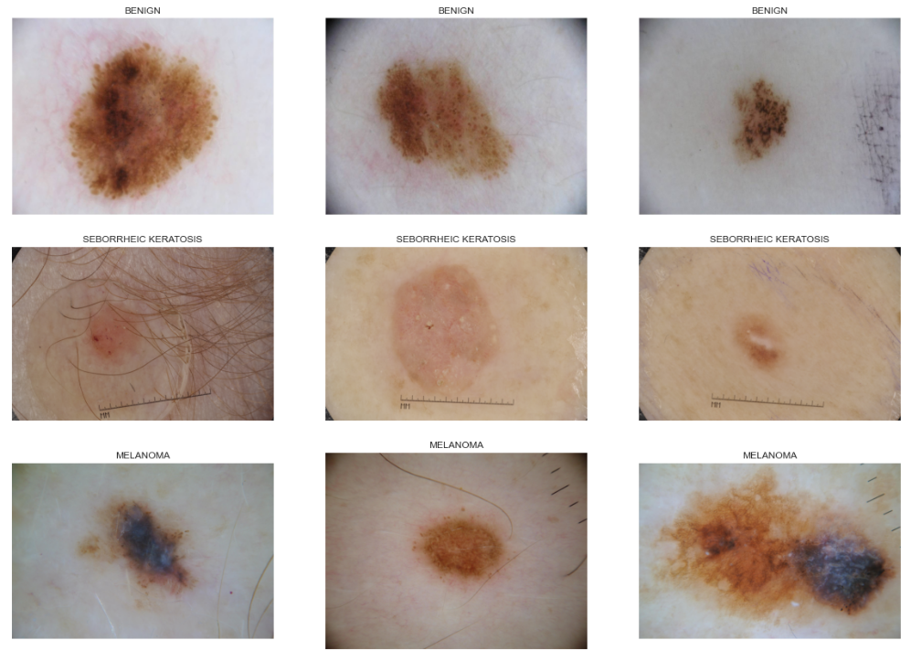

Figure 2: Examples of the various skin cancer types.

### 3.1.2 Exploratory Data Analysis (EDA)

An initial EDA was conducted to understand the characteristics and class distribution of the dataset. A visualization of the class distribution was graphically plotted depicted in (figure 3) to help identify class imbalances, which may impact model performance. The EDA provided essential information on the instance (number of cases) count per class (groundtruth labels), aiding informed decisions on resampling strategies.

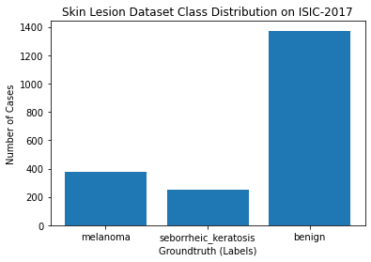 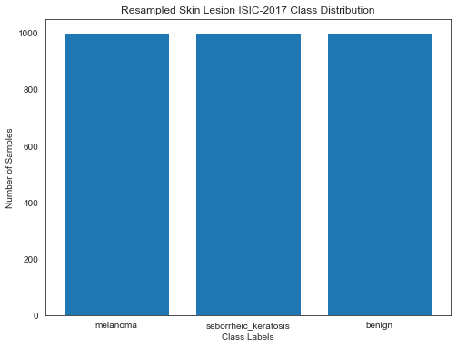

Figure 3: Class distribution of ISIC-2017 dataset. Figure 4: Resampled skin lesion classes.

### 3.1.3 Data Preprocessing and Labelling

To facilitate the classification process, the groundtruth labels are combined to form a single class ("mel_seb_ben"), where melanoma is labeled as 0, seborrheic keratosis as 1, and benign lesions as 2. This consolidation enables a multiclass classification approach, which is vital for accurate and comprehensive skin lesion analysis. Additionally, a mapping is also established for easy interpretation of the "mel_seb_ben" class labels as shown in (figure 5 with red rectangular shape).

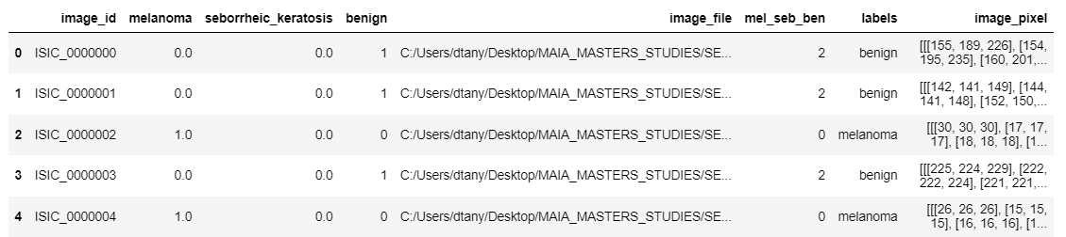

Figure 5: Class labels and image pixels of the ISIC-2017 dataset.

### 3.1.4 Resampling Strategies for Multiclass Classification

To handle the class imbalance, we utilize resampling, employing both oversampling and undersampling techniques. This involves augmenting samples in the minority class and selectively reducing samples from the majority class. Despite the significant class imbalance with benign (1372), seborrheic_keratosis (254), and melanoma (374), a meticulous decision was made to set a "target_samples" count of 1000 per class. This meticulous selection aims to strike a balance between class representation while avoiding overrepresentation of any category. Although this approach ensures an equal number of samples for each class, it is essential to consider real-world scenarios where class distribution might vary. Nevertheless, for this specific study, we adopt this technique to improve the multiclass classification task by enhancing class representation and reducing bias in the skin lesion data as shown in (figure 4).

### 3.1.5 Splitting Data into Training and Test Set

To ensure unbiased evaluation and robust model performance, we carefully split the resampled data into a training set (70%) and a test set (30%). This train-test split approach has been supported by prior research, as cited in notable papers like the one by (Gholamy et al., 2018; Nguyen et al., 2021; Thapar et al., 2022). The 70% (train), 30% (test) split has been extensively used in machine learning studies due to its effectiveness in providing sufficient amount of data for model training, while still offering a relatively large test set for robustly evaluating model performance.

### 3.1.6 Normalizing Image Pixel Values

Prior to model training, our image pixel values were scaled to a common range ([0, 256]), to mitigate the impact of varying image intensities across the dataset. This normalization step proves relevant in our task as we aim to classify three distinct skin lesion types: benign, seborrheic keratosis, and melanoma with varying image pixel intensities. This is depicted in (figure 5 with green rectangular shape).

## 3.2 MULTICLASS SKIN LESION CLASSIFICATION

This section explores two synergistic pathways: a focused pure deep learning exploration and an innovative hybrid approach, combining CNN-based feature extraction with advanced machine learning models. Subsequent sections elucidate these approaches comprehensively.

### 3.2.1 A Pure Deep Learning Approach

This section delves into a focused exploration of a pure deep learning methodology. Here, we integrate a comprehensive strategy for multiclassification of skin lesion which involves data augmentation techniques, a carefully designed Convolutional Neural Network (CNN) architecture, training procedures, and robust performance evaluation metrics.

#### 3.2.1.1 Data Augmentation and Data Generators

Data augmentation techniques were employed to enhance model generalization and prevent overfitting during training. These techniques involved creating new training samples through transformations such as rescaling. This was to expand the training dataset and introduce diversity. The Keras ImageDataGenerator class facilitated seamless implementation of pre-processing, and real-time data augmentation during each training epoch.

#### 3.2.1.2 Convolutional Neural Network (CNN) Model Architecture

The deep learning approach involves using a Convolutional Neural Network (CNN) for skin lesion classification. The CNN architecture comprises sequential multiple layers designed to automatically extract relevant features from input images, capturing both local and global patterns. The CNN model employed three convolutional layers with 256, 128, and 64 filters, respectively, each having different kernel sizes of (1 x 1), (3 x 3), and (5 x 5). This allows the network to capture features at different scales. Smaller kernels (1 x 1) focus on local details and colours, medium-sized kernels (3 x 3) capture more complex patterns, and larger kernels (5 x 5) consider more global context. This multi-scale feature extraction helps the model to learn a wide range of features, enhancing its ability to recognize diverse patterns in the input images and improving its generalization performance in the skin lesion multiclassification task. The model used the "relu" activation function to incorporate non-linearity and capture intricate patterns. The CNN architecture includes max-pooling layers for downsampling and reducing image spatial dimensions. To mitigate overfitting, dropout layers were incorporated in the CNN architecture to randomly deactivate neurons during training. This encourages the network to learn features through multiple pathways.

Also, the architecture is configured with "Flatten" layer to convert the feature maps into a 1-dimensional array. This allows seamless connection to subsequent dense layers. The first dense layer with 32 neurons processes the learned features, capturing higher-level abstractions from the input data. The final dense layer has 3 neurons, representing the three skin lesion classes (benign, seborrheic keratosis, and melanoma). The "softmax" activation function produces probability scores for each class, indicating the likelihood of the input belonging to a specific skin lesion type. The same CNN architecture was leveraged for both approaches of multiclass classification, ensuring consistency and comparability.

Table 2: The summary of the convolutional neural network (CNN) architecture.

|  |  |  |
| --- | --- | --- |
| Layer (type) | Output Shape | Param # |
| conv2d (Conv2D) | (None, 64, 64, 256) | 1024 |
| max_pooling2d (MaxPooling2D) | (None, 32, 32, 256) | 0 |
| dropout (Dropout) | (None, 32, 32, 256) | 0 |
| conv2d_1 (Conv2D) | (None, 30, 30, 128) | 295040 |
| max_pooling2d_1 (MaxPooling2D) | (None, 15, 15, 128) | 0 |
| dropout_1 (Dropout) | (None, 15, 15, 128) | 0 |
| conv2d_2 (Conv2D) | (None, 11, 11, 64) | 204864 |
| max_pooling2d_2 (MaxPooling2D) | (None, 5, 5, 64) | 0 |
| dropout_2 (Dropout) | (None, 5, 5, 64) | 0 |
| flatten (Flatten) | (None, 1600) | 0 |
| dense (Dense) | (None, 32) | 51232 |
| dense_1 (Dense) | (None, 3) | 99 |
| Total params: 552,259  Trainable params: 552,259  Non-trainable params: 0 | | |

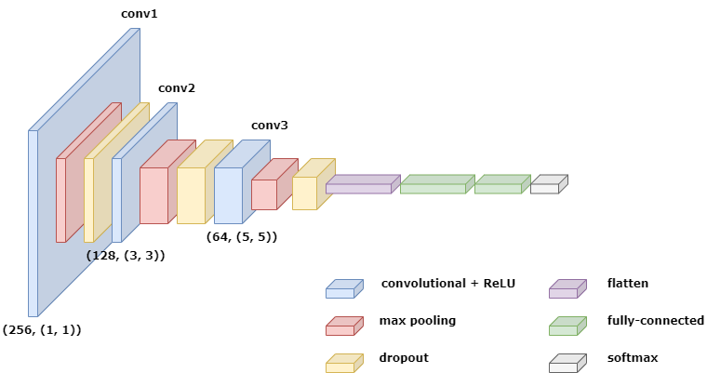

Figure 6: A visual representation of the CNN architecture.

#### 3.2.1.3 Training and Validation Procedures

The CNN model had 552, 259 trainable parameters, representing learnable weights and biases. Augmented data from "train_generator" was used for model training. The Adam optimizer and categorical cross-entropy loss, ideal for multiclass classification were optimized. A batch size of 32 was utilized during model training, optimizing memory usage and computational efficiency. The model was trained for 60 epochs, which means the entire dataset was processed 60 times. During each epoch, backpropagation updated model weights based on prediction error, minimizing the loss function. As training progressed, accuracy improved on both training and validation sets until convergence. (Figure 7) and (figure 8) display the training and validation loss and accuracy plots respectively, for each epoch during the model training process.

#### 3.2.1.4 Performance Evaluation Metrics

To assess the performance of the model for the multiclass classification task, several evaluation metrics including accuracy, precision, recall, F1-score, bma, and confusion matrix were computed on the test set. The accuracy metric was used to measure the overall performance by determining the percentage of correctly classified samples in the test set. The recall metric measures the percentage of true positives identified correctly in the dataset. Precision metric on the other hand, is relevant for evaluating the model's performance in correctly identifying positive instances while minimizing false positives. F1-score, essential in multiclass classification with imbalanced classes, provided a balanced measure of the model's accuracy by considering both precision and recall. It was calculated for each class and then averaged to obtain the macro F1-score. Additionally, the confusion matrix shown in (figure 9) was used to evaluate the model's performance for each class individually, offering insights into false positives and false negatives. (Table 3) presents evaluation metrics for the pure deep learning-CNNs.

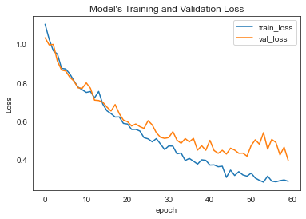 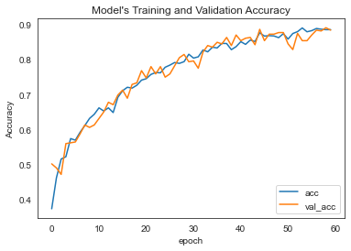

Figure 7: Loss plot of CNN model. Figure 8: Accuracy plot of CNN model.

Table 3: Performance evaluation of the pure deep learning approach using the ISIC-2017 dataset.

|  |  |  |  |  |  |
| --- | --- | --- | --- | --- | --- |
| EVAL. METRIC / MODEL | accuracy | precision | recall | F1-score | bma |
| Pure deep learning-CNNs | 0.8518 | 0.8566 | 0.8518 | 0.8480 | 0.8520 |

### 3.2.2 Hybrid Deep Learning-Machine Learning Approach

This section explores a Hybrid Deep Learning-Machine Learning approach, leveraging their synergies for superior skin lesion multiclassification outcomes. This innovative fusion of methodologies entails strategic steps for feature extraction, scaling, dimensionality reduction, model training, and performance evaluation.

#### 3.2.2.1 Feature Extraction using CNN

In the hybrid deep learning-machine learning approach, we utilize Convolutional Neural Networks (CNNs) for feature extraction, same as the pure deep learning approach. The flattened output of the last layer serves as a feature extractor for the ML classifiers.

#### 3.2.2.2 Feature Scaling (StandardScaler) and Dimensionality Reduction (PCA)

The CNN extracts varying hierarchical features from the images and flattens them into a 1-dimensional array. To ensure consistency in feature magnitudes and mitigate feature dominance, we optimize the StandardScaler function for feature normalization. This function transforms data to have mean and standard deviation values of 0 and 1 respectively. Leveraging this feature scaling technique ensures better generalization ability of ML models.

Furthermore, to reduce the dimensionality of the extracted features and avoid the curse of dimensionality, principal component analysis (PCA) is applied. PCA projects the data from a higher-dimensional space onto a lower-dimensional subspace while preserving the most significant variance in the data. Careful consideration was given to selecting the appropriate number of PCA components. This was to ensure a balance between dimensionality reduction and information preservation trade-off. The optimal PCA value for our multiclass classification task was 70.

#### 3.2.2.3 Training Machine Learning Models

Various ML models, including ensemble methods like random forest classifiers (rf), non-linear algorithms such as k nearest neighbors (KNN), linear algorithms like logistic regression (lm), and advanced algorithms such as support vector machines (SVM) were trained. Supervised learning approach was utilized, where ML classifiers received transformed data with their corresponding labels (benign, seborrheic keratosis, and melanoma) as input. These algorithms learned decision boundaries between skin lesion classes to optimize classification performance on the training set.

Prior to selecting the best model, a 5-fold cross-validation was optimized during ML training to enhance model robustness as displayed in (table 4). This technique divides the data into five folds, training and evaluating the model multiple times. It ensures reliable performance estimation and detects overfitting or underfitting. The rf emerged as the best model, in terms of accuracy and performance and was adopted as the final ML multiclassification model. We optimized the number of estimators (decision trees) in rf to 100, finding a balance between model complexity and performance for our multiclassification task.

Table 4: Cross-validation results of machine learning models on the ISIC-2017 dataset.

|  |  |  |  |  |  |
| --- | --- | --- | --- | --- | --- |
| CROSS VALIDATION / MODEL | 1-fold | 2-fold | 3-fold | 4-fold | 5-fold |
| Random forest (rf) | 0.8571 | 0.8595 | 0.8714 | 0.8714 | 0.8667 |
| Support Vector Machines (SVM) | 0.6238 | 0.6262 | 0.6524 | 0.5952 | 0.6333 |
| K Nearest Neighbors (KNN) | 0.6190 | 0.6881 | 0.6286 | 0.6333 | 0.6548 |
| Logistic Regression (lm) | 0.6214 | 0.6167 | 0.6357 | 0.5810 | 0.6262 |

#### 3.2.2.4 Performance Evaluation Metrics

The same evaluation metrics were leveraged for both approaches of multiclass classification, ensuring consistency and comparability.

Table 5: Performance evaluation of the hybrid deep learning-machine learning approach models using the ISIC-2017 dataset.

|  |  |  |  |  |  |
| --- | --- | --- | --- | --- | --- |
| EVAL. METRIC / MODEL | accuracy | precision | recall | F1-score | bma |
| rf | **0.9056** | **0.9057** | **0.9056** | **0.9050** | **0.9056** |
| SVM | 0.6278 | 0.6253 | 0.6278 | 0.6210 | 0.6278 |
| KNN | 0.6978 | 0.7012 | 0.6978 | 0.6895 | 0.6978 |
| lm | 0.6289 | 0.6210 | 0.6289 | 0.6231 | 0.6289 |

# 4.0 RESULTS, DISCUSSION AND COMPARATIVE ANALYSIS

Our analysis compares pure deep learning using CNNs with an innovative hybrid approach that combines deep learning and machine learning for multiclass skin lesion classification. This analysis evaluates their classification abilities, Balanced Multiclass Accuracy (BMA), and the novel advantages offered by the hybrid model.

## 4.1 Performance Comparison of Pure Deep Learning and Hybrid Approach

We compared two approaches for multiclass skin lesion classification: pure deep learning using CNNs and a hybrid deep learning-machine learning approach. Our goal was to assess their performance in accurately and precisely distinguishing between benign, seborrheic keratosis, and melanoma lesions. Our comprehensive comparative analysis considers the confusion matrices obtained from both approaches to reveal valuable insights into their classification capabilities. The confusion matrix obtained from both the pure deep learning and the hybrid deep learning-machine learning approaches (figure 10) are as follows:

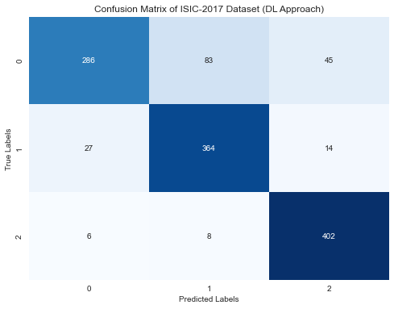 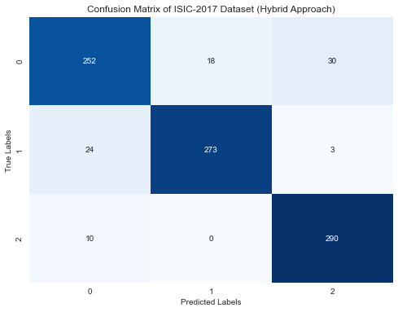

Figure 9: Confusion matrix for pure DL. Figure 10: Confusion matrix for hybrid approach.

*Interpretation of confusion matrix:*

The diagonal elements present in both matrices represent correct predictions, while off-diagonal elements represent misclassifications. Regarding the pure deep learning approach, for the class "melanoma (0)," 286 samples were correctly classified, while 83 were misclassified as "seborrheic keratosis (1)" and 45 as "benign nevi (2)." For the class "seborrheic keratosis," 364 samples were correctly classified, while 27 were misclassified as "melanoma" and 14 as "benign nevi." For the class "benign nevi," 402 samples were correctly classified, while 6 were misclassified as "melanoma" and 8 as "seborrheic keratosis." However, regarding the hybrid deep learning-machine learning approach, for the class "melanoma," 252 samples were correctly classified, while 18 were misclassified as "seborrheic keratosis" and 30 as "benign nevi." For the class "seborrheic keratosis," 273 samples were correctly classified, while 24 were misclassified as "melanoma" and 3 as "benign nevi." For the class "benign nevi," 290 samples were correctly classified, while 10 were misclassified as "melanoma." The pure deep learning approach shows relatively higher misclassifications, especially in distinguishing "seborrheic keratosis" and "melanoma." In contrast, the hybrid approach demonstrates superior classification capabilities with fewer misclassifications, particularly in the "seborrheic keratosis" class. These interpretations highlight the performance of each approach in accurately classifying skin lesion types.

The deep learning approach using CNNs was vital in automatically extracting relevant features before classifying skin lesion types. However, its performance in this multiclassification task was limited in our study due to the relatively small dataset, which hindered effective generalization of complex features associated with different skin lesion types. CNNs excel in learning intricate patterns but require a large amount of data for optimal performance and may overfit with limited data. On the other hand, the hybrid deep learning-machine learning approach achieved remarkable results despite the huge class imbalance in this challenging task. By leveraging CNNs and Random Forest Classifier, it reliably classified skin lesions (benign, seborrheic keratosis, and melanoma). This powerful hybrid approach for multiclassification has great potential for informed medical diagnosis.

Table 6: Comparative evaluation performance of pure deep learning and hybrid deep learning-machine learning approaches using the ISIC-2017 dataset.

|  |  |  |  |  |  |
| --- | --- | --- | --- | --- | --- |
| EVAL. METRIC / MODEL | accuracy | precision | recall | F1-score | bma |
| Random forest (rf) | **0.9056** | **0.9057** | **0.9056** | **0.9050** | **0.9056** |
| Deep learning-CNNs | 0.8518 | 0.8566 | 0.8518 | 0.8480 | 0.8520 |

## 4.2 Balanced Multiclass Accuracy (BMA)

The Balanced Multiclass Accuracy (BMA) serves as an additional standard metric for evaluating the performance of our multiclassification model, considering class imbalances and providing a fair assessment of predictions across all classes. Higher BMA values indicate better overall classification performance. The random forest classifier achieved a 90.56% BMA, showing its effectiveness in accurately classifying skin lesion classes. CNN achieved an 85.20% BMA, slightly lower but still very impressive result considering the dataset size. This further emphasizes the potential of hybrid deep learning-machine learning approach in achieving accurate and reliable multiclass skin lesion classification.

## 4.3 Novelty and Advantages of the Proposed Hybrid Approach

Our innovative hybrid approach combines the automatic feature engineering capability of CNNs with the interpretability and robustness of the Random Forest, an ensemble classifier. This integration provides several key advantages over the conventional pure deep learning approach for skin lesion multiclass classification.

Our hybrid deep learning-machine learning approach effectively handles class imbalances through resampling techniques, improving performance across all lesion types. The interpretability of the Random Forest Classifier fosters trust in diagnostic results. It mitigates overfitting and ensures robustness to unseen data. In achieving higher balanced multiclass accuracy score, it excels in classifying skin lesions in varying scenarios. By incorporating machine learning models in the pipeline and leveraging CNN-based feature extraction, the approach is efficient, and reduces the need for manual feature engineering. Overall, our novel hybrid approach shows promising potential in dermatology for accurate and reliable skin lesion classification.

# 5.0 Case Study: Comparative Performance Analysis on HAM10000 Datasets

Skin lesion classification using advanced machine learning and deep learning techniques has gained significant attention in medical imaging. Accurate diagnosis and early detection of skin diseases, particularly melanoma, are critical for effective patient care. This case study extends the research project titled “Enhancing Multiclass Skin Lesion Classification” to the HAM10000 dataset. The primary objective is to further validate our findings by comparing the performance of the pure deep learning approach and the hybrid deep learning-machine learning approach on this new dataset.

The HAM10000 dataset comprises a diverse set of skin lesion images classified into multiple categories: melanocytic nevi (nv), melanoma (mel), basal cell carcinoma (bcc), benign keratosis-like lesions (bkl), actinic keratoses and intraepithelial carcinoma (akiec), vascular lesions (vasc), and dermatofibromas (df). The dataset is characterized by a varying distribution of samples across these categories, making it a challenging benchmark for skin lesion classification algorithms. By employing the same methodological framework as the original research project, we made a slight modification by meticulously setting the "target_sample" count per class to 2000. The carefully set number was aimed to create a balanced dataset for training machine learning models, especially deep learning models, which can benefit from having a sufficient number of samples for each class. This allowed us to leverage the same proposed algorithms to the HAM10000 dataset, assessing the performance of pure deep learning and hybrid deep learning-machine learning approaches. The resulting performance metrics for each approach are as follows:

Table 7: Comparative evaluation performance of pure deep learning and hybrid deep learning-machine learning approaches using the HAM10000 dataset.

|  |  |  |  |  |  |
| --- | --- | --- | --- | --- | --- |
| EVAL. METRIC / MODEL | accuracy | precision | recall | F1-score | bma |
| Random forest (rf) | **0.9221** | **0.9217** | **0.9221** | **0.9214** | **0.9221** |
| Deep learning-CNNs | 0.8533 | 0.8535 | 0.8533 | 0.8523 | 0.8545 |

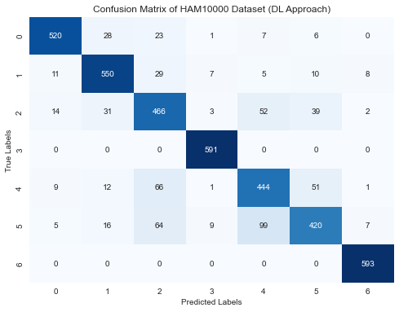 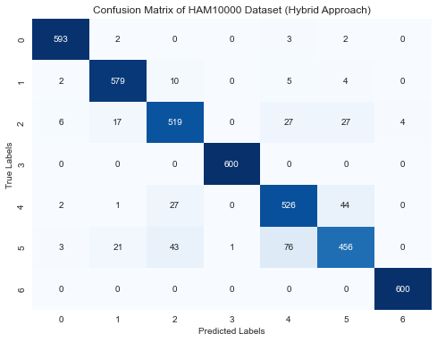

Figure 11: Confusion matrix for pure DL. Figure 12: Confusion matrix for hybrid approach.

The obtained confusion matrices (figure 11 and figure 12) for both the pure deep learning and hybrid deep learning-machine learning approaches on the HAM10000 dataset are indicative of their classification performances. In the pure deep learning approach, slight misclassifications are evident, particularly between dermatofibromas (4) and benign keratosis-like lesions (5) categories, affecting accuracy. Conversely, the hybrid approach remarkably reduces misclassifications across all classes, leading to higher accuracy. These matrices provide a visual representation of the models' strengths and areas for improvement, contributing valuable insights to the overall assessment of the classification methods.

The comparative analysis of the pure deep learning approach and the hybrid deep learning-machine learning approach on the HAM10000 dataset reveals substantial insights into their performance. The pure deep learning approach demonstrates commendable results, achieving high accuracy, precision, and recall. However, the hybrid approach significantly outperforms it across all metrics. The hybrid model's accuracy, precision, and recall values are remarkably high, indicating its exceptional ability to classify diverse skin lesion types.

The case study on the HAM10000 dataset reaffirms the superiority of the hybrid deep learning-machine learning approach, contributing to the advancement of skin lesion classification techniques and their practical application in medical imaging.

# 6.0 FUTURE RECOMMENDATION

While our study presents promising results and advancements in skin lesion multiclassification, several avenues for future research can further enrich the field. Exploration of additional ML models like gradient boosting techniques may achieve higher accuracy and model robustness. Extensive evaluations on larger datasets will validate the proposed hybrid approach in real-world clinical settings. Incorporating explainable AI techniques will enhance DL model interpretability for clinical acceptance. Multi-modal imaging should be explored to fuse complementary information for improved classification accuracy. Collaboration with medical experts for clinical validation will ensure real-world applicability of the proposed hybrid model in healthcare settings.

# 7.0 CONCLUSION

In conclusion, this research project has addressed a significant gap in the field of skin lesion classification by comparing the performance of pure deep learning with a hybrid deep learning-machine learning approach. Skin lesion classification is a critical task in dermatology, aiding in early and accurate diagnosis of various skin diseases, including potentially life-threatening melanoma. The findings of this study highlight the challenges posed by imbalanced datasets and the complexity of skin lesion variations. The hybrid approach, which leverages the strengths of both CNN-based deep learning and Random Forest-based machine learning, has proven to be a superior solution in achieving accurate and reliable multiclassification. Through rigorous experimentation on both the ISIC-2017 and HAM10000 datasets, this research has not only showcased the potential of the hybrid approach but also provided valuable insights into the importance of class imbalance handling, feature scaling, and dimensionality reduction. These insights will undoubtedly serve as a practical springboard for further innovation in AI-powered diagnostic tools, benefiting dermatology and medical imaging as a whole. The successful validation of the hybrid approach on the diverse HAM10000 dataset further validates its potential for real-world clinical application, indicating a promising future for the integration of advanced machine learning and deep learning techniques in medical diagnosis and treatment planning.

# 8.0 REFERENCES

Afza, F., Sharif, M., Khan, M. A., Tariq, U., Yong, H. S., & Cha, J. (2022). Multiclass Skin Lesion Classification Using Hybrid Deep Features Selection and Extreme Learning Machine. *Sensors (Basel, Switzerland)*, *22*(3). https://doi.org/10.3390/S22030799

Alzubaidi, L., Zhang, J., Humaidi, A. J., Al-Dujaili, A., Duan, Y., Al-Shamma, O., Santamaría, J., Fadhel, M. A., Al-Amidie, M., & Farhan, L. (2021). Review of deep learning: concepts, CNN architectures, challenges, applications, future directions. *Journal of Big Data 2021 8:1*, *8*(1), 1–74. https://doi.org/10.1186/S40537-021-00444-8

Atkins, M. B., Curiel-Lewandrowski, C., Fisher, D. E., Swetter, S. M., Tsao, H., Aguirre-Ghiso, J. A., Soengas, M. S., Weeraratna, A. T., Flaherty, K. T., Herlyn, M., Sosman, J. A., Tawbi, H. A., Pavlick, A. C., Cassidy, P. B., Chandra, S., Chapman, P. B., Daud, A., Eroglu, Z., Ferris, L. K., … Merlino, G. (2021). *The State of Melanoma: Emergent Challenges and Opportunities*. https://doi.org/10.1158/1078-0432.CCR-20-4092

Bechelli, S., & Delhommelle, J. (2022). Machine Learning and Deep Learning Algorithms for Skin Cancer Classification from Dermoscopic Images. *Bioengineering 2022, Vol. 9, Page 97*, *9*(3), 97. https://doi.org/10.3390/BIOENGINEERING9030097

Blundo, A., Cignoni, A., Banfi, T., & Ciuti, G. (2021). Comparative Analysis of Diagnostic Techniques for Melanoma Detection: A Systematic Review of Diagnostic Test Accuracy Studies and Meta-Analysis. *Frontiers in Medicine*, *8*, 637069. https://doi.org/10.3389/FMED.2021.637069/BIBTEX

Board, P. A. T. E. (2023). Skin Cancer Treatment (PDQ®). *Bethesda, MD: National Cancer Institute. Updated 02/03/2023. Available at: Https://Www.Cancer.Gov/Types/Skin/Hp/Skin-Treatment-Pdq. Accessed 20/03/2023. [PMID: 26389366]*. https://www.ncbi.nlm.nih.gov/books/NBK65928/

Celebi, M. E., Iyatomi, H., Stoecker, W. V., Moss, R. H., Rabinovitz, H. S., Argenziano, G., & Soyer, H. P. (2008). Automatic detection of blue-white veil and related structures in dermoscopy images. *Computerized Medical Imaging and Graphics : The Official Journal of the Computerized Medical Imaging Society*, *32*(8), 670–677. https://doi.org/10.1016/J.COMPMEDIMAG.2008.08.003

F Codella, N. C., Gutman, D., Emre Celebi, M., Helba, B., Marchetti, M. A., Dusza, S. W., Kalloo, A., Liopyris, K., Mishra, N., Kittler, H., & Halpern, A. (2017). *SKIN LESION ANALYSIS TOWARD MELANOMA DETECTION: A CHALLENGE AT THE 2017 INTERNATIONAL SYMPOSIUM ON BIOMEDICAL IMAGING (ISBI), HOSTED BY THE INTERNATIONAL SKIN IMAGING COLLABORATION (ISIC)*. http://challenge2017.isic-archive.com/

Fong, S., Fortino, G., Ghista, D., & Piccialli, F. (2023). Special issue on deep learning and big data analytics for medical e-diagnosis/AI-based e-diagnosis. *Neural Computing and Applications*, *35*(22), 15961–15965. https://doi.org/10.1007/S00521-023-08689-5/METRICS

Gholamy, A., Kreinovich, V., & Kosheleva, O. (2018). Why 70/30 or 80/20 Relation Between Training and Testing Sets: A Pedagogical Explanation. *Departmental Technical Reports (CS)*. https://scholarworks.utep.edu/cs_techrep/1209

Gilli, I. O., Casagrande Zanoni, A., Pereira De Andrade, D., Amaro, D., & Andrade, S. (2022). Cutaneous melanoma diagnosis delay: socioeconomic and demographic factors influence. *Rev Assoc Med Bras*, *68*(10), 1405–1409. https://doi.org/10.1590/1806-9282.20220369

Hakkoum, H., Abnane, I., & Idri, A. (2022). Interpretability in the medical field: A systematic mapping and review study. *Applied Soft Computing*, *117*, 108391. https://doi.org/10.1016/J.ASOC.2021.108391

Iqbal, I., Younus, M., Walayat, K., Kakar, M. U., & Ma, J. (2021). Automated multi-class classification of skin lesions through deep convolutional neural network with dermoscopic images. *Computerized Medical Imaging and Graphics*, *88*, 101843. https://doi.org/10.1016/J.COMPMEDIMAG.2020.101843

Kassem, M. A., Hosny, K. M., Damaševičius, R., & Eltoukhy, M. M. (2021). Machine Learning and Deep Learning Methods for Skin Lesion Classification and Diagnosis: A Systematic Review. *Diagnostics 2021, Vol. 11, Page 1390*, *11*(8), 1390. https://doi.org/10.3390/DIAGNOSTICS11081390

Khattar, S., & Kaur, R. (2022). Computer assisted diagnosis of skin cancer: A survey and future recommendations. *Computers and Electrical Engineering*, *104*, 108431. https://doi.org/10.1016/J.COMPELECENG.2022.108431

Linardatos, P., Papastefanopoulos, V., & Kotsiantis, S. (2020). Explainable AI: A Review of Machine Learning Interpretability Methods. *Entropy 2021, Vol. 23, Page 18*, *23*(1), 18. https://doi.org/10.3390/E23010018

Maqsood, S., & Damaševičius, R. (2023). Multiclass skin lesion localization and classification using deep learning based features fusion and selection framework for smart healthcare. *Neural Networks*, *160*, 238–258. https://doi.org/10.1016/J.NEUNET.2023.01.022

Michalska-Ciekańska, M. (2022). Multiclass Skin Lessions Classification Based on Deep Neural Networks. *Informatyka, Automatyka, Pomiary w Gospodarce i Ochronie Srodowiska*, *12*(2), 10–14. https://doi.org/10.35784/iapgos.2963

Nguyen, Q. H., Ly, H. B., Ho, L. S., Al-Ansari, N., Van Le, H., Tran, V. Q., Prakash, I., & Pham, B. T. (2021). Influence of data splitting on performance of machine learning models in prediction of shear strength of soil. *Mathematical Problems in Engineering*, *2021*. https://doi.org/10.1155/2021/4832864

Sarker, I. H. (2021). Deep Learning: A Comprehensive Overview on Techniques, Taxonomy, Applications and Research Directions. *SN Computer Science*, *2*(6), 1–20. https://doi.org/10.1007/S42979-021-00815-1/FIGURES/13

Sharma, T., & Shah, M. (2021). A comprehensive review of machine learning techniques on diabetes detection. *Visual Computing for Industry, Biomedicine, and Art*, *4*(1). https://doi.org/10.1186/S42492-021-00097-7

Shen, X., Yu, R. X., Shen, C. B., Li, C. X., Jing, Y., Zheng, Y. J., Wang, Z. Y., Xue, K., Xu, F., Yu, J. Bin, Meng, R. S., & Cui, Y. (2019). Dermoscopy in China: Current status and future prospective. *Chinese Medical Journal*, *132*(17), 2096–2104. https://doi.org/10.1097/CM9.0000000000000396

Tahir, M., Naeem, A., Malik, H., Tanveer, J., Naqvi, R. A., & Lee, S. W. (2023). DSCC_Net: Multi-Classification Deep Learning Models for Diagnosing of Skin Cancer Using Dermoscopic Images. *Cancers 2023, Vol. 15, Page 2179*, *15*(7), 2179. https://doi.org/10.3390/CANCERS15072179

Taye, M. M. (2023). Theoretical Understanding of Convolutional Neural Network: Concepts, Architectures, Applications, Future Directions. *Computation 2023, Vol. 11, Page 52*, *11*(3), 52. https://doi.org/10.3390/COMPUTATION11030052

Thapar, P., Rakhra, M., Cazzato, G., & Hossain, M. S. (2022). A Novel Hybrid Deep Learning Approach for Skin Lesion Segmentation and Classification. *Journal of Healthcare Engineering*, *2022*. https://doi.org/10.1155/2022/1709842

Usama, M., Naeem, M. A., & Mirza, F. (2022). Multi-Class Skin Lesions Classification Using Deep Features. *Sensors 2022, Vol. 22, Page 8311*, *22*(21), 8311. https://doi.org/10.3390/S22218311

van der Weyden, L., Brenn, T., Patton, E. E., Wood, G. A., & Adams, D. J. (2020). Spontaneously occurring melanoma in animals and their relevance to human melanoma. *Journal of Pathology*, *252*(1), 4–21. https://doi.org/10.1002/PATH.5505

Varoquaux, G., & Cheplygina, V. (2022). Machine learning for medical imaging: methodological failures and recommendations for the future. *Npj Digital Medicine 2022 5:1*, *5*(1), 1–8. https://doi.org/10.1038/s41746-022-00592-y

Wu, Y., Chen, B., Zeng, A., Pan, D., Wang, R., & Zhao, S. (2022). Skin Cancer Classification With Deep Learning: A Systematic Review. *Frontiers in Oncology*, *12*, 893972. https://doi.org/10.3389/FONC.2022.893972/BIBTEX

Zeng, L., Gowda, B. H. J., Ahmed, M. G., Abourehab, M. A. S., Chen, Z. S., Zhang, C., Li, J., & Kesharwani, P. (2023). Advancements in nanoparticle-based treatment approaches for skin cancer therapy. *Molecular Cancer 2023 22:1*, *22*(1), 1–50. https://doi.org/10.1186/S12943-022-01708-4